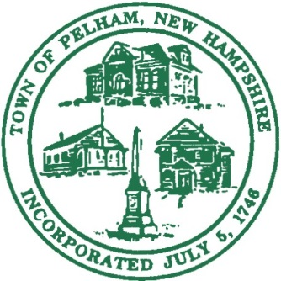
TOWN OF PELHAM
Office of the Selectmen
6 Village Green Pelham, NH 03076
Tel: (603) 635-8233
Fax: (603) 635-8274
Email: selectmen@pelhamweb.com

Application for Tax Exemption on Commercial/Industrial Properties

You must apply for the exemption BEFORE starting construction or renovation but not after DECEMBER 31 before the beginning of the tax year for which the exemption is sought.

Date: ______________ Property Address:______________________________________

Name of Business: __________________________________________________________

Property Owner: ___________________________________________________________

Owner Phone & Email:________________________________________________________

Applicant and Title: _________________________________________________________

Applicant Phone & Email:_____________________________________________________

________ New Construction ______ Addition ______ Renovation

Building Permit Number: __________________Please include a copy of the Plan with this application.

Brief description of the public benefit of the construction work to be done: ________________________________________________________________________________________________________________________________________________________________________________________________________________________________________________________________________________________________________________

Start Date: __________ Estimated Completion Date: _______________

Estimated Cost of Project: __________________________

As voted by the Town at the March 14, 2023, town meeting, the exemption shall apply only to the municipal and local school portion of property taxes for the increase in assessed value as a result of this construction project and shall exclude the state education and county property tax.

The percentage of authorized exemption is as follows:

  - Year 1 to Year 5, 50% of the increased assessment value

  - Year 6, 40% of the increased assessment value

  - Year 7, 30% of the increased assessment value

  - Year 8, 20% of the increased assessment value

  - Year 9 and Year 10, 10% of the increased assessment value

I have read and understand the above conditions of this exemption. By signing below, I affirm that I am authorized to sign this application on behalf of this entity.

_________________________________________________________________
Signature of Property Owner Date

----------------------------------------------------------------------------------------------------------------------------
For Board of Assessors only:
__________________
Date of Approval

_______________________________ _________________________________
Jason Croteau Jaie Bergeron

_______________________________ _________________________________
Heather Corbett Charlene Takesian

______________________________
Danielle Masse Quinn

